**The following are the submission fields required on the HeroX submission page.**

**Questions:**

* Are the ATtiny85’s the final microprocessors, even though they’re 8bit?
  + Nope, have been replaced with the pic24 thing
* How do the lines on the schematic relate to the payload/rover main connector pinout?
  + Have updated schematic to reflect rover’s connector pinout
* Does the payload in fact operate at 8V input from the rover?
  + Yes
* What is the continuous and peak power?
  + Peak: when solenoids are on
  + Continuous: average between solenoid and magnetometer power
* What are this payload’s data rate, processing requirements, and bandwidth?
  + Max data rate of around 100Hz when querying rover location every second or so. Data is stored on the rover.
  + No processing from rover besides querying the rover location
  + Bandwidth is very small too
* Are the electronics in the schematic capable of accomodating the following requirements?:
  + Accepting all interference from hosting space craft on 900MHz and 2.4GHz frequencies
  + Communicating interrupts to the rover
    - Yes
  + Communicating a heartbeat to the rover
    - Yes
  + Being soft reset and turned off by the rover
    - Yes
  + “Maximum continuous data rate from payload to spacecraft is limited by downlink to hosting mission and will be approximately 1-2 kb/s”
    - If data were transmitted throughout mission rather than (or in addition to being stored), wouldn’t have more than 100 b/s
  + “Data will not be stored by the hosting spacecraft or lander” - does the payload have memory capabilities or room to include memory if needed?
    - Yes memory can fit
* Are the following points from the project requirements required for communication between payload and rover, or are they informational about what resources are available to the payload from the rover:
  + “The spacecraft (rover) will provide an asynchronous UART TX/RX at 115 kbaud per second”
    - Unsure if required, but the new microprocessor supposedly has two UART modules so I assume that means it supports this
  + The spacecraft (rover) will provide one SPI master at 1 Mbits/s
    - Also unsure if this is required, but the new microprocessor supposedly has two 4-wire SPI modules so I assume that means it supports this, too

# Title (50 characters max)

Payload for locating lunar ferromagnetic materials

# Short Description (140 characters max)

Our design magnetizes ferromagnetic resources on the lunar surface with solenoids, and detects their presence with a fluxgate magnetometer.

# How did you hear about this challenge? (100 characters max)

This challenge was suggested to us through a HeroX “new challenges” email

# Full name + email address of each participating team member

Kelsey Towers-Jones, [kelseytj97@gmail.com](mailto:kelseytj97@gmail.com)

Aila Simpson, [aila@simpsonirving.com](mailto:aila@simpsonirving.com)

Scott Pederson, [spederson314@gmail.com](mailto:spederson314@gmail.com)

Chris Hansen, [chrisfrancohansen@gmail.com](mailto:chrisfrancohansen@gmail.com)

# Submission Category

The lunar resource potential

# Proposed payload overview

“Please provide an overview of your proposed payload, its capabilities, and its technical maturity”

On Earth, ferromagnetic materials can be located due to their detectable local influences on Earth’s magnetic field, but since the moon lacks a strong even magnetic field, locating lunar ferromagnetic materials is dependent on being able to independently generate a strong enough magnetization field. Our payload design uses a solenoid to generate a sufficiently strong magnetization field, and a small, sensitive fluxgate magnetometer to detect changes in the ambient magnetic field pre- and post- magnetization that could be indicative of the presence of valuable ferromagnetic materials like iron, nickel, and cobalt.

# Payload capabilities

“Please discuss in detail what your payload consists of, what it does, and why this is important. Be sure to make clear the connection between the payload capabilities and their impact on bridging your selected knowledge gaps. What will be the impact of this payload if it is successfully developed and deployed?”

**Don’t hesitate to reference figures - add any figures to the list below (or just list their file name + upload them to the google drive folder). Figures will be extra-appreciated by judges!!!!!**

Our payload contributes to NASA’s efforts to characterize the lunar resource potential by enabling use of a miniature fluxgate magnetometer to identify high concentrations of ferromagnetic materials such as iron, cobalt, and nickel in the regolith. Fluxgate magnetometers are commonly used for geomagnetic surveying and prospecting on Earth, but those used in these applications are typically too big to fit in the prescribed payload volume, and depend on the existence of the Earth’s magnetic field to identify materials.

Since the moon does not have a strong or consistent magnetic field, our payload instead generates its own magnetic field using a solenoid to magnetize ferromagnetic materials in the lunar surface regolith, and then uses small, high-temperature, high-sensitivity fluxgate magnetometers to detect the change in ambient magnetic field before and after magnetization by the solenoid. The operation sequence is illustrated in Figure 1 in the Supporting Files and Figures section.

First, with the solenoid turned off, the magnetometer senses the ambient magnetic field at the rover location. Then, the solenoid turns on to deliver a “burst” of magnetic field strong enough to magnetize ferromagnetic regolith deposits underneath the rover. Finally, the solenoid turns off to allow the magnetometer to sense the ambient magnetic field again and compare its measurement to the measurement of the pre-magnetization field. An increase in the ambient field following the solenoid’s magnetization burst would indicate that there are ferromagnetic materials in the regolith at the rover location that had been magnetized by the payload’s solenoid.

Figure 1 also shows that the payload includes a secondary “protection” solenoid. This solenoid opposes the primary magnetization solenoid’s field at the magnetometer’s location to prevent the fluxgate magnetometer’s core from being magnetically saturated during the magnetization burst. The fluxgate magnetometer’s sensing capabilities depend on its core not being magnetically saturated.

The minimum individual ferromagnetic particle size that can be sensed by the payload is dependent on both the intensity of the magnetic field that can be generated by the magnetization solenoid, and on the sensitivity of the fluxgate magnetometer. Our chosen magnetometer can sense magnetic field intensities between 0.268 and 2000μT [1].

Given the mean magnetic susceptibility data for various lunar material samples analyzed by Rochette, et al [2], our payload can detect individual ferromagnetic particles as small as 1.2mm in diameter for lower magnetic susceptibility materials (logχ = 2.41 from meteorite samples), and as small as 0.26mm in diameter for higher magnetic susceptibility materials (logχ = 4.39). This is calculated assuming particles of ferromagnetic materials on the moon can be approximated by spheres.

Ian Crawford in his review of lunar resources points out that “crashed metallic asteroids on the lunar surface may...prove to be economically valuable” [3]. This payload could enable a rover to locate crashed meteor locations with valuable concentrations of ferromagnetic resources like iron, nickel, and cobalt, and other lunar locations with significant concentrations of similar ferromagnetic resources that could be used in future material processing and manufacturing processes on the moon. This directly addresses the knowledge gap of identifying regolith with high concentrations of iron, and their distribution.

[1] Texas Instruments, “DRV425 Fluxgate Magnetic-Field Sensor,” SBOS729A, October 2015. [Online]. Available: <http://www.ti.com/lit/ds/symlink/drv425.pdf?ts=1591468645343&ref_url=https://www.google.com/>

[2] Rochette, P., Gattacceca, J, Ivanov, AV, Nazarov, MA, Bezaeva, NS, “Magnetic properties of lunar materials: Meteorites, Luna and Apollo returned samples,” *Earth and Planetary Science Letters*, vol. 292, no. 3-4, pp. 383-391, 1 April 2010. [Online]. Available: <https://www-sciencedirect-com.ezproxy.library.uvic.ca/science/article/pii/S0012821X10001093?via%3Dihub>

[3] Crawford, I.A., “Lunar resources: A review,” *Progress in Physical Geography*, vol. 39, no. 2, pp. 137-167, 2015. [Online]. Available: <https://journals.sagepub.com/doi/10.1177/0309133314567585>

# Technical Maturity

“Please discuss the technical maturity of your proposed payload. What TRL would you assign it? Please provide a supporting rationale and/or evidence for this rating. Why do you believe this could be developed and deployed in 1-4 years?”

Don’t hesitate to reference figures - add any figures to the list below (or just list their file name + upload them to the google drive folder). Figures will be extra-appreciated by judges!!!!!

We have demonstrated proof-of-concept for our design through calculations of its magnetization and sensing abilities, and through demonstrating that it is possible to implement the necessary magnetization and sensing equipment in a volume as small as the lunar microrover payload volume. Therefore, we assign our design a TRL of 3.

For reference, the 5 equations detailed in the following text are also summarized in nice formatting in Figure 2. These equations define the theoretical basis of our design’s capabilities.

For a solenoid with its axis pointed at the lunar surface, the intensity of magnetic field produced by the solenoid measured at the lunar surface is given by Equation 1: B = μ02m/(4πx3), where μ0 is the magnetic permeability of free space, x is the distance between the lunar surface and the center of the solenoid, and m is the magnetic moment of the solenoid [4]. The magnetic moment of the solenoid is given by Equation 2: m = NIπr2, where N is the number of turns in the solenoid, I is the solenoid’s current, and r is the radius of the solenoid [5].

The degree to which materials on the lunar surface magnetize in response to the magnetization solenoid’s field is described by the materials’ magnetic susceptibility property. For a material with a given magnetic susceptibility, the magnetization strength can be calculated by Equation 3: M = χH, where M is the magnetization in the material, χ is the material’s magnetic susceptibility, and H is the magnetizing field strength [6].

A few assumptions are made when establishing the equations for determining the sensor’s ability to detect the field produced by magnetized materials after the magnetization solenoid has turned off:

* The materials’ magnetization does not decay significantly before the sensor can make its measurement
* The shape of valuable ferromagnetic material deposits on the moon can be approximated as spheres
* The material particles are uniformly magnetized by the magnetization field
* The strength of the magnetized particles’ field doesn’t vary significantly between the magnetizing solenoid’s location and the magnetometer’s location in the payload
* The vector

Then, the strength of a magnetized particle’s field at the fluxgate magnetometer’s location in the payload above the particle is given by Equation 4: B = (μ0/4π)( - m/r3 + 3(m·r)r/r5 ), where r is the vector distance between the sphere and the magnetometer location [7]. Another assumption made is that the vector directions of the magnetized material’s field and the distance r are parallel enough that the equation can be evaluated as a scalar equation without significantly impacting the validity of the conclusions drawn about the method’s feasibility based on these equations. Thus, Equation 4 reduces to B = (μ0/2π)(m/r3), where m in this case is calculated by Equation 5: m = 4πa3M, where a is the radius of the magnetized particle, and M is the particle’s magnetization defined by Equation 3 [7].

Using these equations, we sourced high-temperature fluxgate magnetometers that can operate in the lunar environment, and determined that it is possible to fit a solenoid in the payload volume that can generate a magnetization field strong enough to magnetize ferromagnetic particles on the lunar surface to a detectable degree. We characterized our payload’s minimum sensing limits around its ability to detect single particles, but the payload’s performance in practice would likely be somewhat better when it is magnetizing numerous particles at a time, as is more likely to occur on the lunar surface.

While this payload design fulfills a valuable need in NASA’s plan to harness the lunar resource potential, it is also a very simple design that our team is fully capable of manufacturing, prototyping, testing, and refining in two years or less. Its major components are no more than two solenoids, a few very small, high-temperature single-axis fluxgate magnetometers, and a PCB with a microprocessor to drive its operation. As well, all components can fit in the prescribed payload volume with room to spare for dimension adjustments and some additional features as needed, as shown in the NLMP-00-01 PDF drawings in the Supporting Figures and Files section.

[4] More, H., “Magnetic induction at a point on the axis and the equator,” *The Fact Factor*, 15 November 2019. [Online]. Available: <https://thefactfactor.com/facts/pure_science/physics/magnetic-induction/5019/>

[5] Spendier, K., Class Lecture, Topic: “Magnetic fields of solenoids.” PES1120, Department of Physics and Energy Science, University of Colorado Colorado Springs, Colorado Springs, CO, 2014. [Online]. Available: <https://www.uccs.edu/Documents/kspendie/PES1120spring2014/lectures/L31.pdf>

[6] Collings, E.W., “Magnetic Susceptibility,” in *Applied Superconductivity, Metallurgy, and Physics of Titanium Alloys*. New York: Plenum Press, 1986, p. 275. [Online]. Available: <https://link.springer.com/chapter/10.1007/978-1-4613-2095-1_7>

[7] Fitzpatric, R., “Uniformly Magnetized Sphere,” *Classical Electromagnetism*, 27 June 2014. [Online]. Available: <http://farside.ph.utexas.edu/teaching/jk1/lectures/node61.html>

# Project Plan

“If you were to move forward and develop this proposed payload, what would your preliminary project plan look like? Please provide a timeline, a budget, and a list of any additional resources you would need.”

1. Prototyping: Acquiring materials and components to make a version of the payload per the designs submitted
   1. 2 months
   2. Budget ~$500 for components listed in BOM in NMLP-00-01 PDF attached.
2. Pre-testing: Designing and fabricating magnetically isolated test environment
   1. 1 month
   2. Budget ~$500 for magnetic isolation chamber and sample ferromagnetic particles and dusts for test sensing.
3. Testing: Determining the sensing range of the prototype payload, comparing sensing results to estimates from design stage
   1. 1 month
   2. Minimal budget.
4. Refinement: Evaluating sensing range, working with magnetism experts to characterize and improve device operation + follow-up prototyping and testing
   1. 3 months
   2. Budget ~$500 for any new materials, remanufacturing, or purchase of alternative components.
5. Final manufacture and official write-up of device performance
   1. 1 month
   2. Budget ~$500 or less depending on how many parts and materials can be reused from prototyping.
6. Flex time: as a student design team, our availability is occasionally limited due to assignments and other responsibilities. However, we are still dedicated workers and so we doubt this project’s development would take any more than 2 years including time for interruptions and delays.

# Compliance with Small Lunar Payload User’s Guide requirements

“Please discuss how your proposed payload addresses the requirements listed in the Small Lunar Payload User’s Guide. Be sure to note any exceptions or possible issues, describe why they are important/unavoidable, and offer possible mitigation strategies.”

Don’t hesitate to reference figures - add any figures to the list below (or just list their file name + upload them to the google drive folder). Figures will be extra-appreciated by judges!!!!!

**Geometry, mass, and basic operational restrictions:** Our payload fits within the geometry limits of 50x100x100mm, and meets the 0.4kg max weight requirement with a weight of 378.2g (refer to NMLP-00-01 PDF drawing in Supporting Files and Figures section).

The interfacing bearing surfaces and threads meet the keep-out zone and surface requirements outlined in the Small Lunar Payload Users Guide.

The payload incorporates the specified connector in the specified location. The payload does not incorporate any deployables.

**Materials and offgassing:** Our payload primarily uses aluminum 7075 for its main mounting plate, copper magnet wire for its solenoids, PTFE for its solenoid supports, and standard PCB materials along with both aluminum and PEEK fasteners (note: one set of fasteners in the BOM is listed as titanium only because McMaster Carr didn’t have the needed fastener size in aluminum). The PCBs are designed to be encapsulated in space-grade epoxy.

The outgassing properties of these materials falls within the TML 1% max and CVCM 0.1% max limits.

The right-angle connectors found for the fluxgate magnetometer PCBs are of unknown material, but could become permanent connections by being encased in epoxy to mitigate outgassing hazards if they are not made of minimally outgassing plastics.

The mounting plate coefficient of thermal expansion matches that of the rover, and galvanically matches the rover by being made of aluminum.

No forbidden materials or dangerous stored energy units are included in our payload design.

**Thermal limits and environmental protection:** The chosen electronics can operate in the high temperature conditions near the surface of the moon. The lowest operational temperature threshold is for the right-angle connectors at 105C, although they are somewhat shaded from lunar surface temps by being hidden in the secondary protection solenoid.

The fluxgate magnetometers would be the most sensitive part of the payload to lunar dust hazards, so a dustcap is fitted over the end of the secondary protection solenoid, and its other end is butted up against the PCB above it. A hole is included in the PCB above the center of the protection solenoid for pressure equalisation during launch.

We do not know how to determine if our payload will be tolerant to single event effects due to Solar Proton Flux, Solar Heavy Ion Flux, Galactic Ray Proton Flux, and Galactic Cosmic Ray Heavy Ion Flux.

Assuming the chassis ground is achieved through contact between the bearing surfaces of the mounting plate and the rover, the mounting plate is thus grounded to chassis ground. The solenoids are also grounded.

**EMI/EMC, Power, and Data:** The components detailed in the payload’s electrical schematic attached in the Supporting Files and Figures section are the main components required for its primary magnetization and sensing operation. While the schematic does not explicitly include components for communicating with the rover over the 900MHz and 2.4GHz frequencies, there is plenty of space to expand the PCB to easily include such components. As well, our team is capable of carrying out future Conducted Emissions, Conducted Susceptibility, Radiated Emissions, and Radiated Susceptibility testing for our payload.

The main PCB maps to the rover pinout as required, and includes interrupt, heartbeat, and soft-reset and power cycling capabilities via the rover. The payload is powered at the rover’s 8V through the primary bus and is tolerant to immediate, unanticipated power loss.

The PIC24EPXXXGP202 microprocessor can support both UART and SPI communication with the rover. Our payload has plenty of room to expand the PCB to make room for onboard memory that is not currently included in our main schematic, so our payload could handle local data storage until the end of each mission since neither the rover nor the lander will be storing data. Similarly, the payload is capable of handling all its data processing locally, so no data processing is required from the rover besides querying the rover’s position to go with each measurement.

Since the payload only needs at most 0.5 seconds to take its magnetic field measurements, its max data rate during data transmissions would be on the order of 100 b/s, well below the max data rate limit of 1-2 kb/s. The bandwidth would be similarly low; the DRV425 magnetometers have a bandwidth of 32kHz, but given that their sampling time will be low and data will be stored locally, the overall payload bandwidth will be relatively low.

# Supporting Files and Figures

“Please upload any supporting documentation here. Examples of supporting documentation include schematics, tables, figures, diagrams, or video. Note that supporting literature should be referenced in the relevant sections, with links provided if appropriate.”

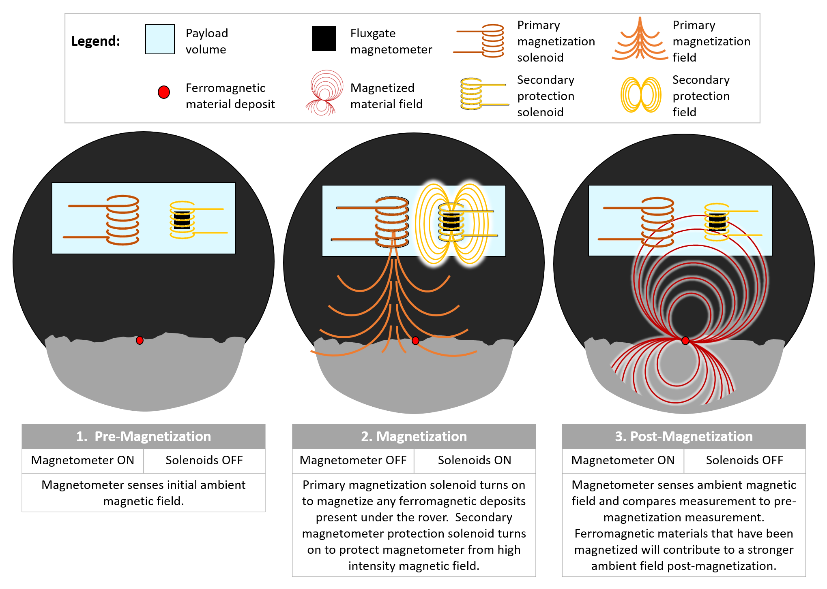

**Figure 1:** Diagram of the payload operation sequence

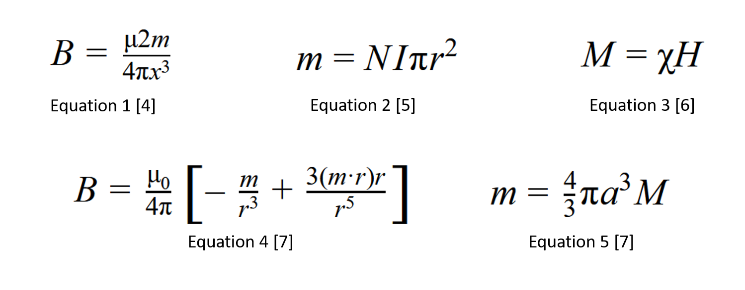

**Figure 2:** Nicely formatted equations referred to in the Technical Maturity evaluation section.

PDF of payload 3D design overview

3D PDF of payload

PDF of schematic

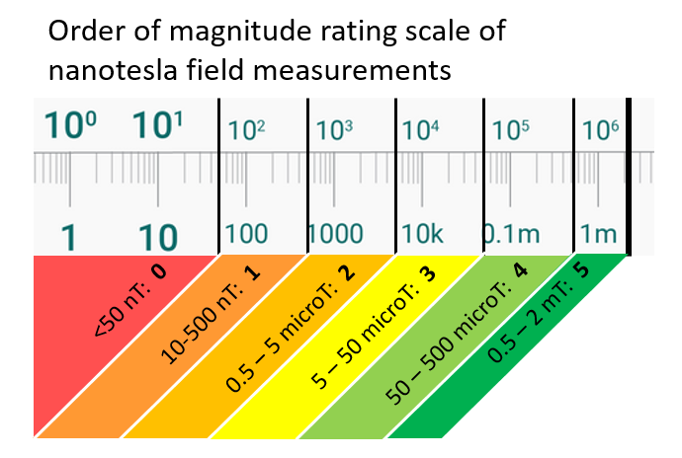

**Figure 3:** Payload rating scale of ambient magnetic field changes due to magnetization

Payload Specs and Capabilities

# Payload Title (3000 characters max)

“Example: payload for miniaturized rovers”

Ferromagnetic Resource Identification with ElectromagNetic Devices (FRIEND): Payload for magnetizing and detecting ferromagnetic materials on the lunar surface

# Instrument Name (3000 characters max)

Texas Instruments DRV425 single-axis fluxgate magnetometer for detecting weak magnetic fields

# Image, diagram, and/or schematic

Required here

Refer to Electrical Schematic PDF

# Team

“Include names and roles/expertise for each team member”

Kelsey Towers-Jones: Practical implementation of magnetism theory, CAD

Aila Simpson: Electronics consultant

Scott Pederson: Research support

Chris Hansen: PCB design

Instrument Characteristics

# Dimensions (mm)

Total Payload: 100mm x 100mm x 50mm (note: about the size of a pack of 16 Kraft Singles)

# Mass (grams)

Mass: 378.2g

# Power (W)

Peak power: 8W for less than 50ms when solenoids perform magnetization burst.

Continuous power: 6.01W, also for less than 50ms at a time when magnetometers perform their measurements.

Even though these power ratings aren’t needed for very long during payload operation steps, they could still be considered a little bit high. This could be mitigated by reducing the overall payload voltage requirement by using capacitors to build up the charge needed to run the solenoids’ magnetization burst.

# Voltage (V)

8V

# Thermal (C): Operating Range

“What is the allowable temperature range when the payload is operating?”

The DRV425 magnetometers are operable between -40°C and 125°C. The main PIC24EPXXXGP202 microprocessor is operational up to 125°C.

The ADC is operational up to 105°C, although is located closer to the -Z face of the payload where the average radiative condition is given as max 80°C.

The ATtiny85 microprocessors are operational up to 85°C, although they too are located closer to the 80°C -Z face of the payload.

# Thermal (C): Unpowered Range

“What is the survivable temperature range when the payload is powered off?”

The DRV425 magnetometers, ADC, and PIC24EPXXXGP202 microprocessor can be stored in temperatures between -65°C and +150°C.

# Data Rate

Max data rate of around 100 b/s

# Processing Requirements

“Includes requirements for processing data, payload operation, and communication”

Our payload handles its own data processing and storage, but will query the rover for position data for each measurement.

# Bandwidth/Resolution

“Maximum instrument capability”

Max bandwidth of 32 kHz

# Precision/Accuracy

“Maximum instrument capability”

The TI DRV425 detects magnetic field intensities up to ±2mT, with a noise level of 1.5nT/√Hz.

At a bandwidth of 32 kHz, it can detect magnetic fields as weak as 0.268μT.

# Instrument Objectives

“What is your instrument trying to do?”

Detect the presence of ferromagnetic materials based on differences in ambient magnetic field measurements before and after magnetization of the lunar surface by the onboard solenoid.

# Physical measurement conducted by instrument

“Actual measurement by instrument (ex. Fluorescence, photon absorption etc)”

Magnetic field intensity

# Analysis of measurement

“What on-board data processing does the instrument perform?”

Payload stores the pre-magnetization field measurement, the post-magnetization field measurement, and the difference between the two. As well, according to the magnetometer’s sensing range (max ±2mT) and noise level (1.5nT/√Hz), it would assign a rating between 0 and 5 corresponding to the payload’s estimation of the likelihood of there being useful amounts of ferromagnetic material at the rover location based on the difference between the ambient field measurements pre- and post-magnetization. The scale is shown in Figure 3 in the Supporting Files and Figures section.

The payload transmits (via the rover) a data string of the measurement values, their difference, the payload’s rating for the location, and the rover location queried by the rover for storage and heavier data analysis elsewhere.

# State of the art Comparison

“Compare to similar instruments or other methods of achieving the same information”

Ferromagnetic materials could also be identified by spectroscopy methods rather than magnetic methods. However, mass spectrometry relies on physically interacting with a sample of material for analysis/ As well, while Raman spectroscopy does not need to physically interact with a sample, no Raman spectroscopy instruments are available commercially in a small size that could be readily adapted for use in these payloads. Our payload instead can distinguish ferromagnetic materials with a relatively small device without any need for physical interaction with samples.

Other methods for detecting magnetic fields include Hall effect sensors for detecting stronger fields, and magneto-inductive magnetometers for detecting very weak fields. Magneto-inductive magnetometers can offer comparable resolution to the DRV425 fluxgate magnetometer, but are harder to come by commercially compared to the options for small fluxgate magnetometers.

Other fluxgate magnetometers exist, but they are typically too big to fit alongside the magnetization and protection solenoids while still meeting the overall max weight limit for the payload. As well, few still can withstand lunar temperatures as the DRV425 fluxgate magnetometer can.

# Impact to NASA

“How will this help NASA learn more about lunar resources and the lunar surface? How will this impact NASA’s mission?”

This payload will help NASA map surface-level distribution of ferromagnetic iron-, nickel-, and cobalt-rich regolith and meteorite deposits, and locate areas with potentially mineable resource concentrations.

# What’s the detection limit and over what period of time?

“How much time do you need for “sampling”, at what resolution?”

The DRV425 magnetometer has a max settling time of 8µs when detecting small signals. Any sampling time greater than this should be plenty for drawing conclusions from the measured data.

The DRV425 magnetometer cannot detect magnetic fields greater than ±2mT.

# Ideal placement on micro-rover

“Where should it be placed? Top? Bottom? Side?”

Bottom

# Ideal lunar site

“What is the best latitude for the measurements you’re trying to make?”

Between approximately 15°S to 60°N on the near side of the moon, in the Ocean of Storms (18.4°N 57.4°W), Sea of Tranquility (8.5°N 31.4°E), or Sea of Rains (32.8°N 15.6°W) - these are all areas identified by the Clementine mission to be most abundant in iron compared to other lunar areas. These areas are indicated in the map of the near side of the moon attached as Figure 4 in the Supporting Files and Figures section.

# Ideal positioning in environment

“Is the instrument looking down? Up? Over the horizon?”

Pointing down, with +Z face pointing at and exposed to lunar surface

# Mechanical Stability requirements

“Does the instrument need to be stable for a period of time for the measurements?”

The payload would need to be relatively for at most 0.5 seconds while the magnetometer makes its measurement, but small vibrations likely wouldn’t ruin the measurements.

# Thermal Requirements

“How many Watts are you dissipating, and to what temperature does your instrument need to be held, in order to make accurate measurements?”

The solenoids dissipate a total of 2W. The magnetometers can make accurate measurements as long as the payload temperature does not exceed the +Z face radiative condition temperature of 120°C.

# Environmental Hazards

“Do you have any special operational precautions?”

Depending on the rover’s construction, its electronics could be negatively affected by the magnetization bursts from the solenoids. To mitigate this hazard, we recommend incorporating some sort of magnetic shielding in the payload or rover as needed to divert the magnetization flux away from any sensitive electronics onboard the rover.